Name: ___Mary Oh______

Student ID: ____1208325416_____

Date: ___04.18.18_____

**Instructions:** You should have at least six pages of your site completed by the time you submit this. Use the following to have a written discussion about the current progress of your website. After you answer the questions below, insert a screenshot of each of the pages you have completed so far (remember, you should have at least 6).

**How do you feel your website is coming along?**

I think the website is coming along really well. Every page is done except for the doctor’s access page, as well as the content of the pages. Once the beta is done, the pages should have more content.

**Since your last update, have you encountered any issues? If so, describe what they were and how you resolved them.**

None really so far.

**Your final project is almost done, outline what you have left and how you plan on completing it:**

All I have left are the contents. It will all be coming along pretty well once the project is done. I also have to figure out how to do the doctor’s page. Maybe a mock database and result will be added to check if it’s working. I also have to figure out how to have the sub nav to scroll down to the specific content that the sub nav corresponds to (ie having the “Risks” under “What’s expected?” nav to scroll down to the part of the body that talks about the risks).

**If you haven’t already, describe where you would like to use a form on your website. Draw a simple sketch of how it will look (what fields will be included, any basic styling, etc.) and paste it below:**

I have added a form.

**With your site almost done, has your sitemap changed? If so, revise your previous sitemap and insert it below:**

No changes has been done.

**OPTIONAL (NOT REQUIRED FOR THE CLASS OR FACTORED INTO YOUR GRADE): If you took advantage of the “Getting Online” video in the Week 6 / Chapter 12 folder and setup a domain and hosting, what were your thoughts on the process? Did you run into any issues? What domain did you pick? Did you upload your files?**

**Screenshot of Page #1**

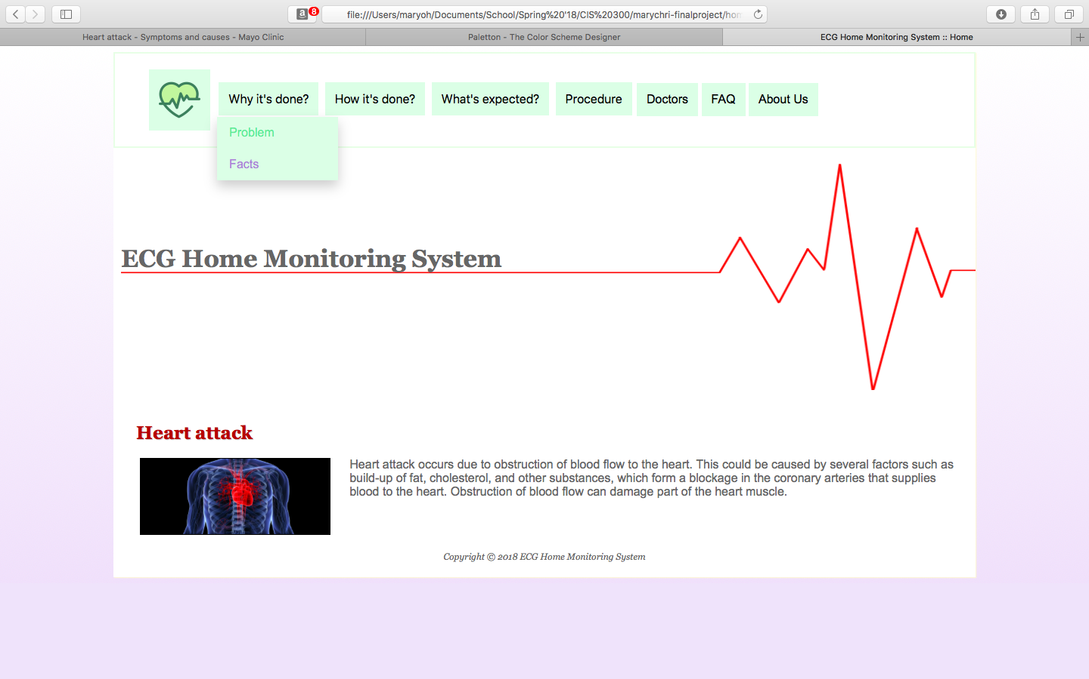

**Screenshot of Page #2**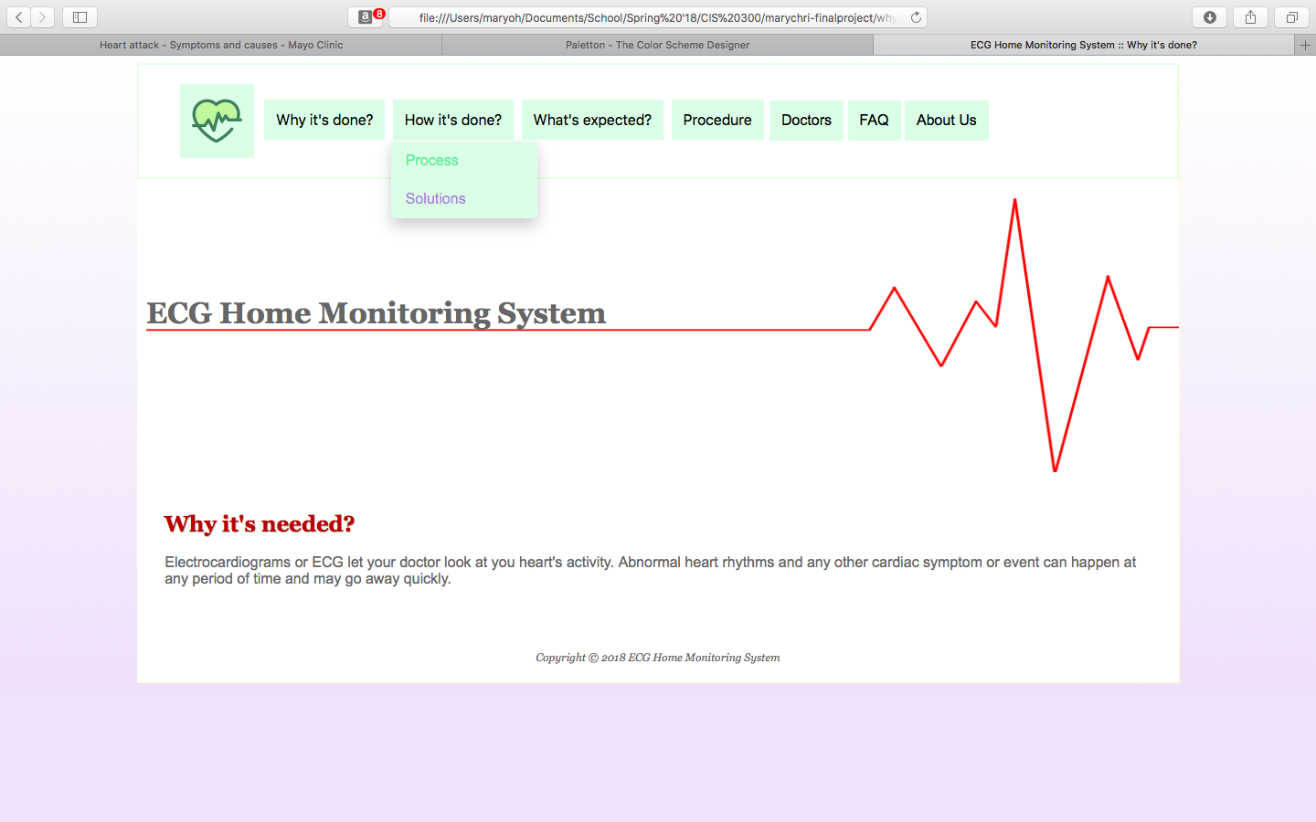

**Screenshot of Page #3**

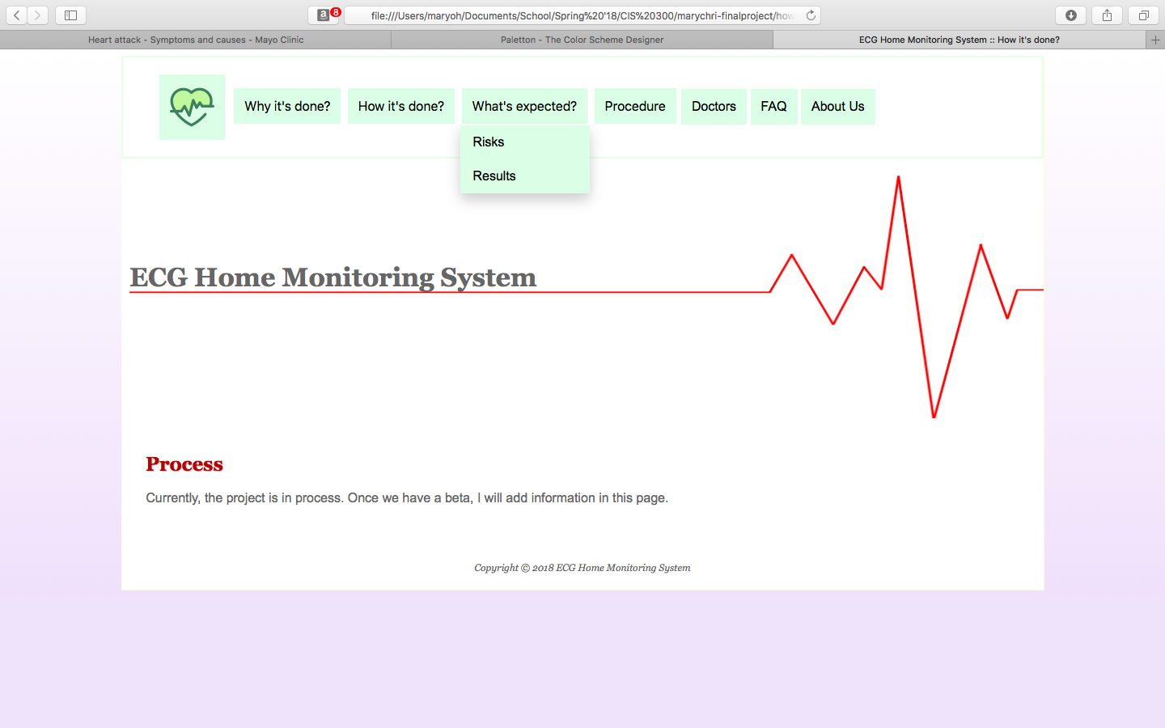

**Screenshot of Page #4**

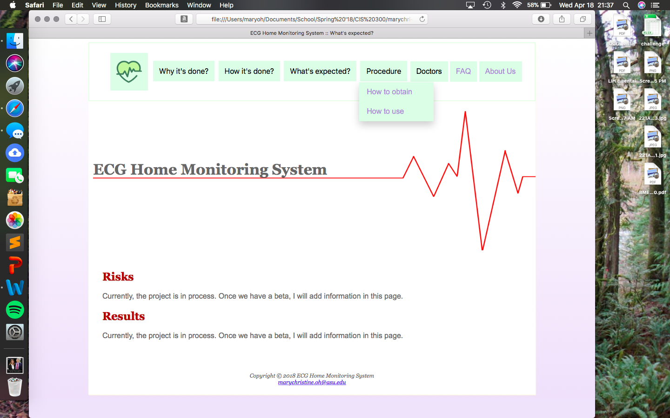

**Screenshot of Page #5**

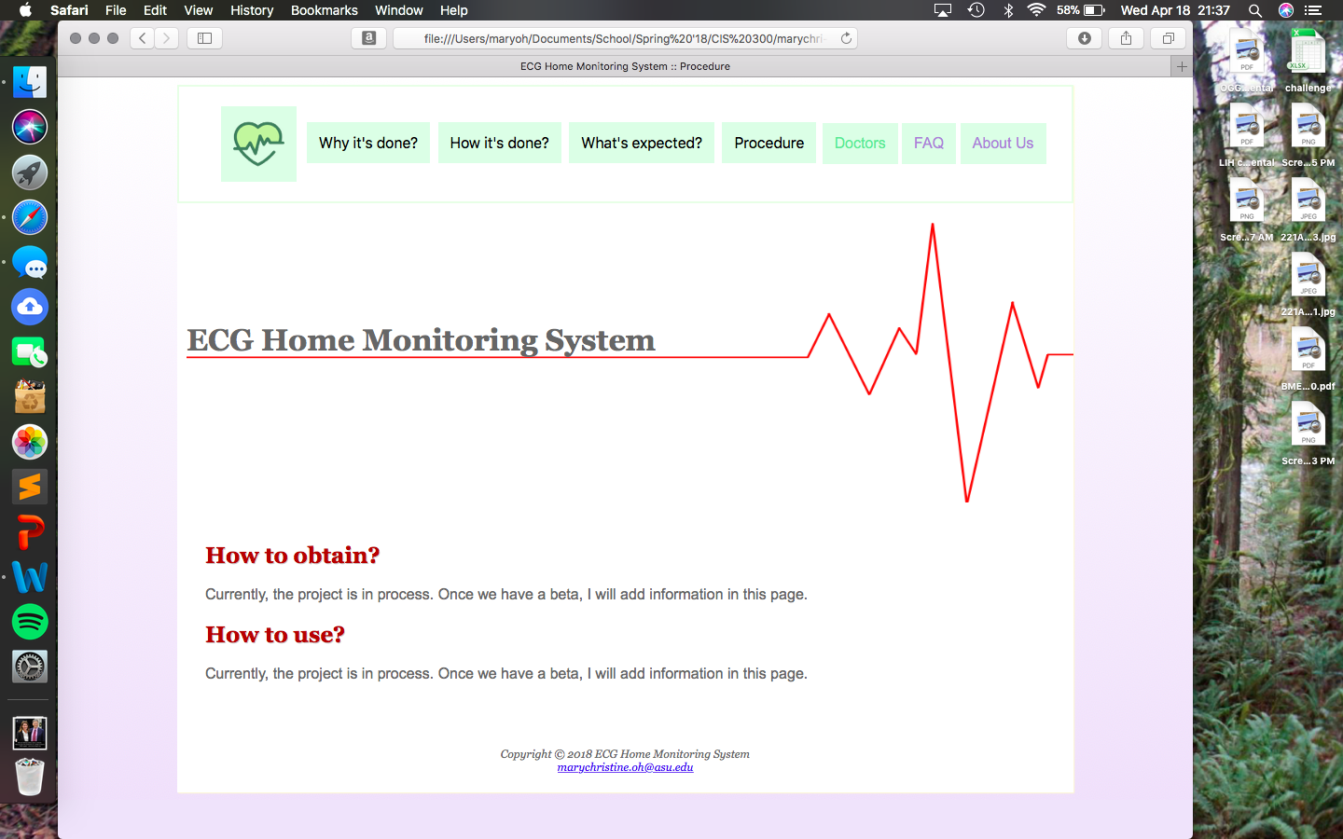

**Screenshot of Page #6**



